**IMPLEMENTATION AND RESULT**

Following are the screens of the Employee Management System where you can see all the features of this system in use and you can also see the GUI of the system:

**Login frame** – This is the login frame of this system where user have to enter the required credentials to have access for the main dashboard.

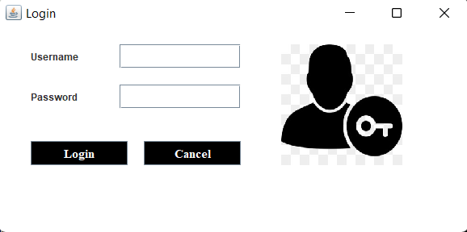

**Main Dashboard** – After login in, user is directed to the main dashboard of this system where user can perform various operations like adding an employee, deleting an employee

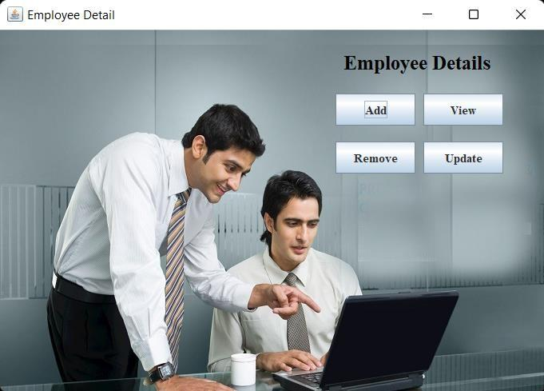

**Add employee** – Here user have to enter all the required credentials to add a new employee to the system.

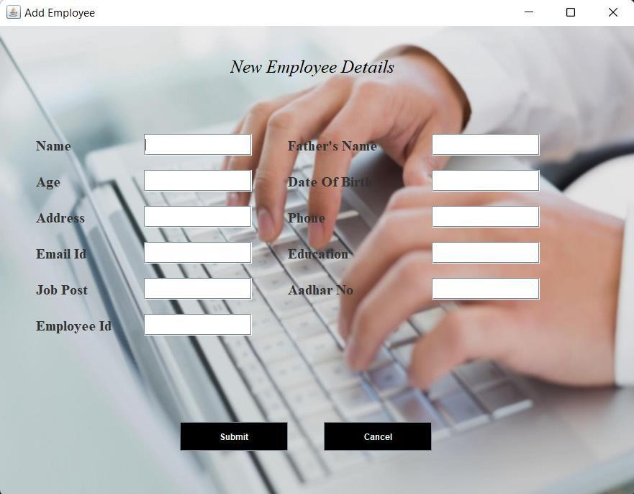

**Remove employee** – User has to enter the employee id in order to delete his information from the system.

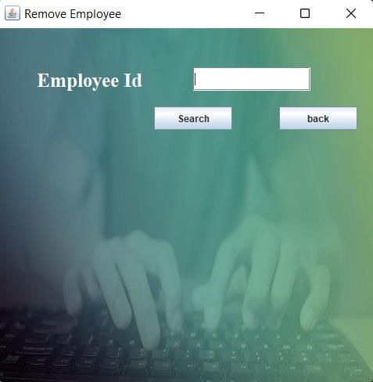

**View and update employee** – In order to view and update employee information, the user have to enter employee ID.

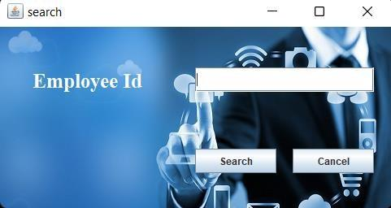

**Testing**

|  |  |  |  |  |  |
| --- | --- | --- | --- | --- | --- |
| **Test ID** | **Test- Purpose** | **Test-Condition** | **Expected-Output** | **Output** | **Remark** |
| TC1 | Check Username & Password | If user details are not correct, display error message | Grant access to main dashboard. | Access granted to main dashboard | Test successful |
| TC2 | To add new user to the system | If user already exists, error message should be displayed. | New user should be added. | New user added successfully | Test Successful |
| TC3 | To view existing employee information | If employee exists, then information should be displayed, else error message should be displayed. | Employee information should be displayed. | Employee information displayed. | Test Successful |
| TC4 | To remove an employee | If employee exists, then employee should be removed else error message should be displayed. | Employee should be removed. | Employee removed successfully. | Test Successful |
| TC5 | Update employee information | If employee exists, then information should be updated. | Employee information should be updated. | Employee information updated successfully | Test Successful |